6th Sunday of Easter
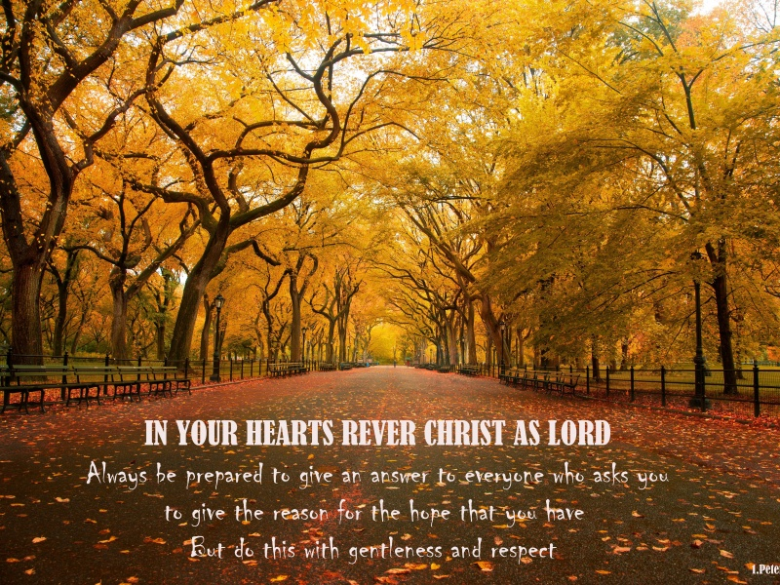

First Reading. Acts 8:5-8, 14-17
A reading from the Acts of the Apostles
Philip went down to the city of Samaria and proclaimed the Christ to them. The crowds with one accord listened eagerly to what was said by Philip, hearing and seeing the signs that he did, for unclean spirits, crying with loud shrieks, came out of many who were possessed; and many others who were paralysed or lame were cured. So there was great joy in that city.
Now when the Apostles at Jerusalem heard that Samaria had accepted the word of God, they sent Peter and John to them. The two went down and prayed for them that they might receive the Holy Spirit (for as yet the Spirit had not come upon any of them; they had only been baptized in the name of the Lord Jesus.) Then Peter and John laid their hands on them, and they received the Holy Spirit. (Acts 8:5-8, 14-7)

Responsorial Psalm: Psalm 65: 1-7, 16, 20
Response: Let all the earth cry out to God with joy
Cry out with joy to God all the earth,
O sing to the glory of his name.
O render him glorious praise.
Say to God: ‘How tremendous your deeds! Resp:

‘Before you all the earth shall bow;
shall sing to you, sing to your name!’
Come and see the works of God,
tremendous his deeds among men. Resp:

He turned the sea into dry land,
they passed through the river dry-shod.
Let our joy then be in him;
he rules for ever by his might. Resp:

Come and hear, all who fear God.
I will tell what he did for my soul:
Blessed be God who did not reject my prayer
nor withhold his love from me.
Let all the earth cry out to God with joy. Resp:

Second Reading. 1 Peter 3:15-18
A reading from the first letter of St. Peter
In your hearts sanctify Christ as Lord. Always be ready to make your defence to anyone who demands from you an accounting for the hope that is in you; yet do it with gentleness and reverence. Keep your conscience clear, so that, when you are maligned, those who abuse you for your good conduct in Christ, may be put to shame. For it is better to suffer for doing good, if suffering should be God's will, than to suffer for doing evil.
For Christ also suffered for sins once for all, the righteous for the unrighteous, in order to bring you to God. He was put to death in the flesh, but made alive in the spirit. (1 Pet. 3:15-18)

Gospel Acclamation John 14: 23
Alleluia, Alleluia!
All who love me will keep my words,
And my Father will love them and we will come to them.

Alleluia!

Gospel Reading. John 14:15-21
Jesus said to his disciples, 'If you love me, you will keep my commandments. And I will ask the Father, and he will give you another Advocate, to be with you forever. This is the Spirit of truth, whom the world cannot receive, because it neither sees him nor knows him. You know him, because he abides with you, and he will be in you.
I will not leave you orphaned; I am coming to you. In a little while the world will no longer see me, but you will see me; because I live, you also will live. On that day you will know that I am in my Father, and you in me, and I in you.
They who have my commandments and keep them are those who love me; and those who love me will be loved by my Father, and I will love them and reveal myself to them.' (Jn. 14:15-21)

Reflections:
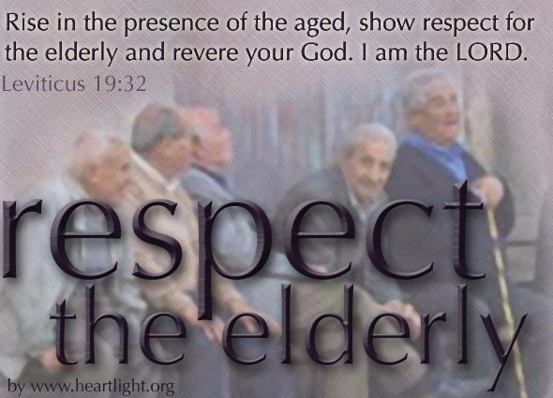
Some of the social formalities of the past are now a dim memory. Our teachers and priests used to be greeted with a salute when we passed them in the street. Other adults we called “Sir” or “Ma’am” and deferred to them. Similar courtesies were expected as good manners. Something of the kind survives in rural area where, as a mark of respect for the dead people still bow their heads when a funeral passes by. Now most of these formalities have gone, like the world of my childhood which valued them so highly.
Many of the old-time courtesies were undermined by the cinema and television, which linked freedom and informality. The screen personalities, cow-boys and crooks, cops and hoodlums, were not noted for courtly manners. They shot from the hip, verbally as well as with six-guns. Many an audience, like eager students, were ready shed their manners like an over-coat. Nowhere seems immune to flippant informality. Even in the church we seem to have lost some of our habits of reverence.
“Revere the Lord in your hearts,” says Saint Peter. This reverence should reach out into all our other relationships too. If, on the contrary, reverence for God is lost, nothing is truly sacred anymore. And, as a quiet warning to people engaged in religious debate, in Australia and elsewhere, St. Peter urges us to make our arguments “with courtesy and respect,” qualities that are notably lacking in the discussion of political and social issues on our ubiquitous media. Reverence for God, respect and courtesy for others are parts of the same virtue. Not all courteous persons are explicit followers of Jesus Christ, but neither is a discourteous person ever a true followers of his way.
“It is better to suffer for doing good, if suffering should be God's will, than to suffer for doing evil.” (1Pet 3:16)

